**It’s a great time to get involved**

With so many changes happening in the NHS and our move to a new Health Centre now is a great time to make sure that your voice is heard.

**Working together**

Help us to ensure that we offer the best possible service to our patients. The way ahead is working together so please support your **P**atient **P**articipation **G**roup in any way that

you can.

You may contact the Group in writing and in confidence c/o Oldham Medical Services, Langham House, 368 Ashton Road Oldham, OL8 3HF



**Where can I find more information about Patient Participation Groups?**

You may like to take a look at : [www.growingppgs.com](http://www.growingppgs.com)

which is a joint initiative run by NAPP, The Royal College of GPs,

the British Medical Association and the NHS Alliance.

**Patient**

**Participation**

**Group**

**Our Practice Patient Participation**

**Group meets at regular intervals**

**to discuss developments in**

**local health services and ways of**

**making a positive contribution to**

**the services and facilities**

**offered by Oldham Services.**

**Find out more about us in this leaflet**

**Oldham Medical Services**

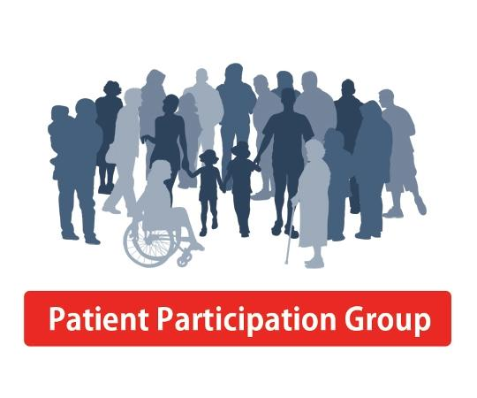

⮚ Linking in with patients who are

Carers or who may ask for

additional support in areas

where PPG members may have

specific skills or experience.

⮚ Arranging health education activities within the practice.

**When does the Group meet?**

The Group meets every quarter for one and a half hours.

**How are the members chosen?**

Members of the group have volunteered to join.

**Do members of the Practice team attend the meetings?**

Yes. There is representation from a manager or administrator.

**Does the group have any other local influence?**

The group also provides representation at Locality meetings looking at the wider development of health and social services for the Oldham.

**How can I get involved?**

If you are interested in joining the group then please ask at reception for a registration form. Alternatively you may write to the PPG and wish the Group to pass on suggestions or comments for discussion at a meeting with Practice representatives.

**What is a Patient Participation Group? (PPG)**

At its simplest, patient participation is about registered patients being more actively involved in their practice.

The idea is for patients and staff to work together to share ideas to help patients to take more responsibility for their own health and help improve the services offered at the Practice.

How is this done?

⮚ By providing feedback from

patients on such things as

appointment systems,

consultation times, repeat

prescriptions, clinics, health

information, etc.

⮚ Helping to obtain patient views

via Surveys and Questionnaires.

⮚ Exploring the changing needs of

patients.

⮚ Assisting with the development

of new services.

⮚ Offering practical help at times

such as busy flu vaccination

clinics in ensuring that patients

are comfortable.

